**PERBAIKAN NILAI UTS**

**MATA KULIAH ALGORITMA & PEMROGRAMAN**

* **NOMOR (3)**

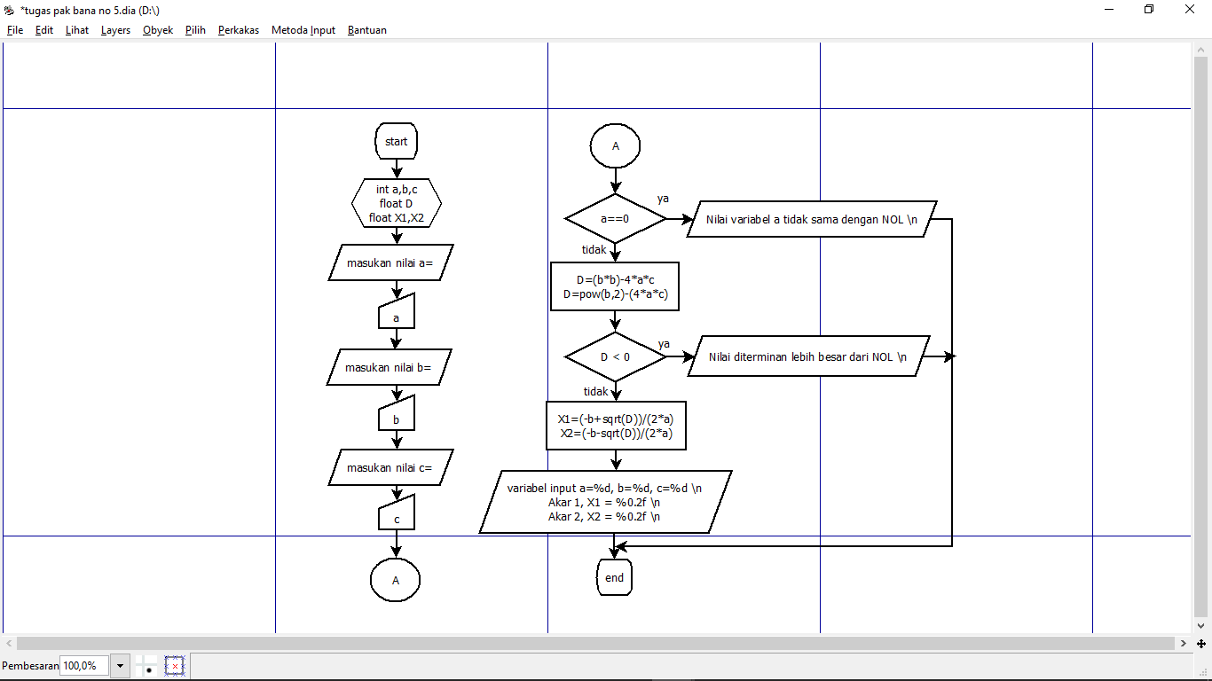

* **NOMOR (4)**

#include <stdio.h>

int main()

{

char A=0;

char SIMBOL;

int DESIMAL;

float HEXADESIMAL;

printf("______________________________________\n\n");

printf("|SIMBOL| DESIMAL|HEXADESIMAL|\n");

printf("______________________________________\n");

for (A=48; A<123; A++)

{

printf("| %c | %d | 0x%x |\n",A,A,A);

}

printf("______________________________________\n");

return 0;

}

* **NOMOR (5)**

#include <stdio.h>

#include <math.h>

int a,b,c;

float D,X1,X2;

int main()

{

a!=0; D>0;

printf("masukan nilai a= \n");

scanf("%d",&a);

printf("masukan nilai b= \n");

scanf("%d",&b);

printf("masukan nilai c= \n");

scanf("%d",&c);

D=(b*b)-(4*a*c);

printf("nilai dari D = %f\n",D);

if(a!=0)

{

X1=(-b+sqrt(D))/(2*a);

printf("nilai dari X1= %f\n",X1);

X2=(b+sqrt(D))/(2*a);

printf("nilai dari X2= %f\n",X2);

}

if(D>0)

{

X1=(-b+sqrt(D))/(2*a);

printf("nilai dari X1= %f\n",X1);

X2=(b+sqrt(D))/(2*a);

printf("nilai dari X2= %f\n",X2);

}

return 0;

}